Topic
Mexican Libraries of 20th Century (BibliotecasMexicanas del Siglo XX)

Related Next Library Theme
Innovation

Authors
- Ruben Rubi (http://nextlibrary.net/users/ruviruben)
- Heber Lopez (http://nextlibrary.net/users/heberlopezcano)

Abstract
This poster session will present the project “Mexican Libraries of the 20th Century” (BibliotecasMexicanas del Siglo XX) that was launched in January 19 2011 by the President of Mexico Felipe Calderon, with the opening of the Jose Luis Martinez Collection in the Mexico Library, one of the most important libraries in this country.
This project is part of the strategies of the National Council of Culture and Arts (CONACULTA) to build a state policy of culture in Mexico, and is a unique initiative to recover the personal libraries of emblematic Mexican people from the 20thcentury, such as writers, historians, philosophers and scientists. These collections will be installed in special spaces built in Mexico Library Jose Vasconcelos, located in Mexico City, and will be open for all citizens.
As a complement to this project, the Autonomous University of Estado de Mexico is digitizing the most important books of the “Mexican Libraries of the 20th Century”, following a special and automated procedure designed by CONACULTA and the University, all the digital books can be consulted by users inside the library, and those which are free of copyright will be available on internet for all public libraries and users; and delivered in external hard drives to public libraries without or weak internet connectivity.
The recently open Jose Luis Martinez Collection has more than 70,000 items and is considered one of the biggest collection of Mexican history and literature, the venue was built specially for this collection with advanced systems of temperature and humidity control, and some personal belongings of this author has been set on the library to work also as an small museum. The library has four rooms for users, confortable furniture and a Wi-Fi network; equipped with a total of eight computers, users can ask for an Ipad or netbook to work inside the library and consult the digital books. The next “Mexican Libraries of the 20th Century” will be the Antonio Castro Leal Collection, with 50,000 items; this library will open at the end of 2011.
The biggest value of this project is to preserve the Mexican memory of the 20th century recovering this wonderful personal libraries, the last personal libraries with this great printed collection; this value is summarized in the Twitter Consuelo Saizar, President of CONACULTA (@Csaizar): "I am convinced that the eBook will not end the printed books, but it will threaten the personal libraries"...
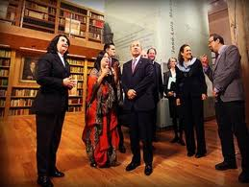
Jose Luis Martinez Collection open in January 2011

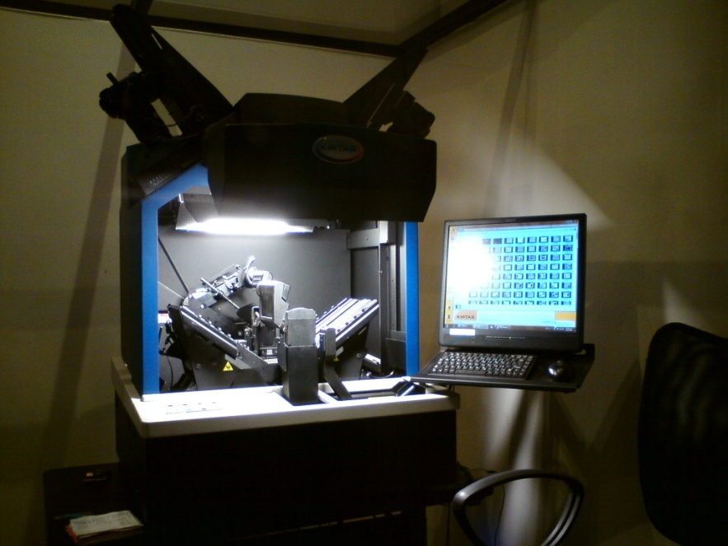
Digitizing room of the “Mexican Libraries of the 20th Century” project
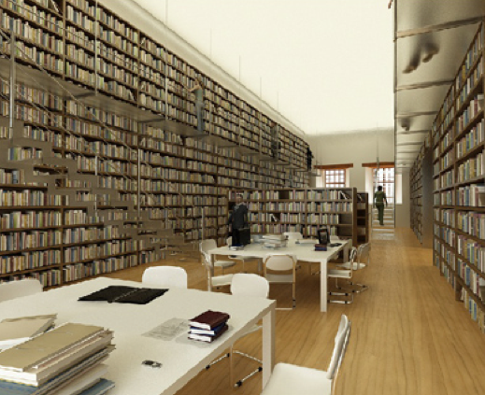
How will look the Antonio Castro Leal Collection

